THANK YOU all for coming. After our weather emergency and rescheduling, we expected a small turnout. This speaks to the level of admiration and feeling for Glen. It is a mighty tribute.

Today I am sincerely celebrating Glen's life.

It was RICH and FULL.

It was a life dedicated to the service of others.

If you re-read his obituary, you'll see how many volunteer service organizations he worked with over his long adult life.

So I want to begin our discussions today about REMEMBERING GLEN T. NYGREEN with some memories about my father.

One of my earliest includes asking "Dad, can I sleep over at Johnnie's on Saturday?" and not getting a simple YES or NO answer. Instead, Glen embarked on Socratic questioning, making me answer the question by thinking about various issues and drawing the answer out. Just like a DEAN!

My father had values and he adhered to them all his life. He was virtuous; he didn't smoke or drink. His only indulgence may have been overeating… Glen was honest, a straight arrow, upstanding, ethical, "pure." I honestly never knew of anything he did that was "bad" or "wrong" or embarrassing.

The Sigma Alpha Epsilon fraternity has a Creed called the True Gentleman.

This is a beautifully succinct definition. People have told me that nobody lives up to this better than Glen Nygreen:

The True Gentleman is the man whose conduct proceeds from good will and an acute sense of propriety, and whose self-control is equal to all emergencies; who does not make the poor man conscious of his poverty, the obscure man of his obscurity, or any man of his inferiority or deformity; who is himself humbled if necessity compels him to humble another; who does not flatter wealth, cringe before power, or boast of his own possessions or achievements; who speaks with frankness but always with sincerity and sympathy; whose deed follows his word; who thinks of the rights and feelings of others, rather than his own; and who appears well in any company, a man with whom honor is sacred and virtue safe.

A fitting description of Glen T. Nygreen: True Gentleman.

Another theme that I grew up with is Glen's definition of "success." As you might expect, it has nothing to do with wealth or fame. Glen wrote about his career in education:

"My professional life has been spent as an administrator of colleges… I have had fun and challenge wherever I have been. That seems to me to be what success is all about. When one gets up in the morning and feels each day to be a challenge and enjoyable, then one should be considered successful. It isn't about money or public acclaim or high status that counts, after all, but rather the evidence of responsibility and service in whatever you have undertaken."

Indeed, his life was service-oriented.

I received the following email tribute PACO PADIN-SAN MARTIN who is in Spain taking care of his own father:

"Much as I am saddened by Glen's death, I also feel nothing but gratitude in my heart for the kind of miraculous life that he led, touching so many of us so deeply, making sure that a piece of him lives on through each one of our lives and each one of the deeds he inspired in us...extending his reach far beyond his own life and times. What an honor to have shared a bit of his time on earth, to have been mentored by such a wise, compassionate and generous human being, and what an exquisite pleasure for me personally to have had the opportunity to publicly acknowledge and extend to him my heartfelt thanks for his contributions to my life.

"Glen Nygreen lives. He's a part of me, a part of you and the same can be said for countless others."

Those of us who have been close to Glen for the past few years have seen aging gradually take its toll.

Frail.

Energy levels much decreased.

Memory failing (well, most of us suffer from that affliction…)

But Glen remained vibrant and vital and interested in intellectual and social progress. Even though his body and mind were slowed by age, he stayed engaged and involved as best he could.

He had a bumper sticker on the car: Do justice, Seek peace, Build community

In fact, PEACE was Glen's consistent message:

He especially liked to quote one of the Beatitudes, blessings from Jesus recorded in the Sermon on the Mount: *"Blessed are the peacemakers, for they shall be called the children of God."*

In his Reflections on Outreach in 1985 and again in 2003, Glen wrote *"Is not the making of peace the premier task of our time?"*

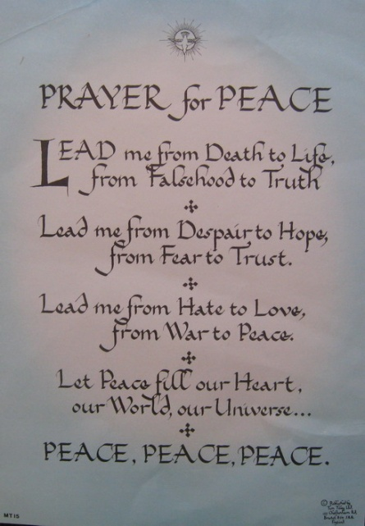On his desk was this PRAYER for PEACE:

Lead me from Death to Life, from Falsehood to Truth

Lead me from Despair to Hope, from Fear to Trust.

Lead me from Hate to Love, from War to Peace.

Let Peace fill our Heart, our World, our Universe…

I think that's a fitting memory of Glen – a lifelong peacemaker.

We will miss him, and we shall strive to carry on his mission.

Ted Nygreen  
February 26, 2010