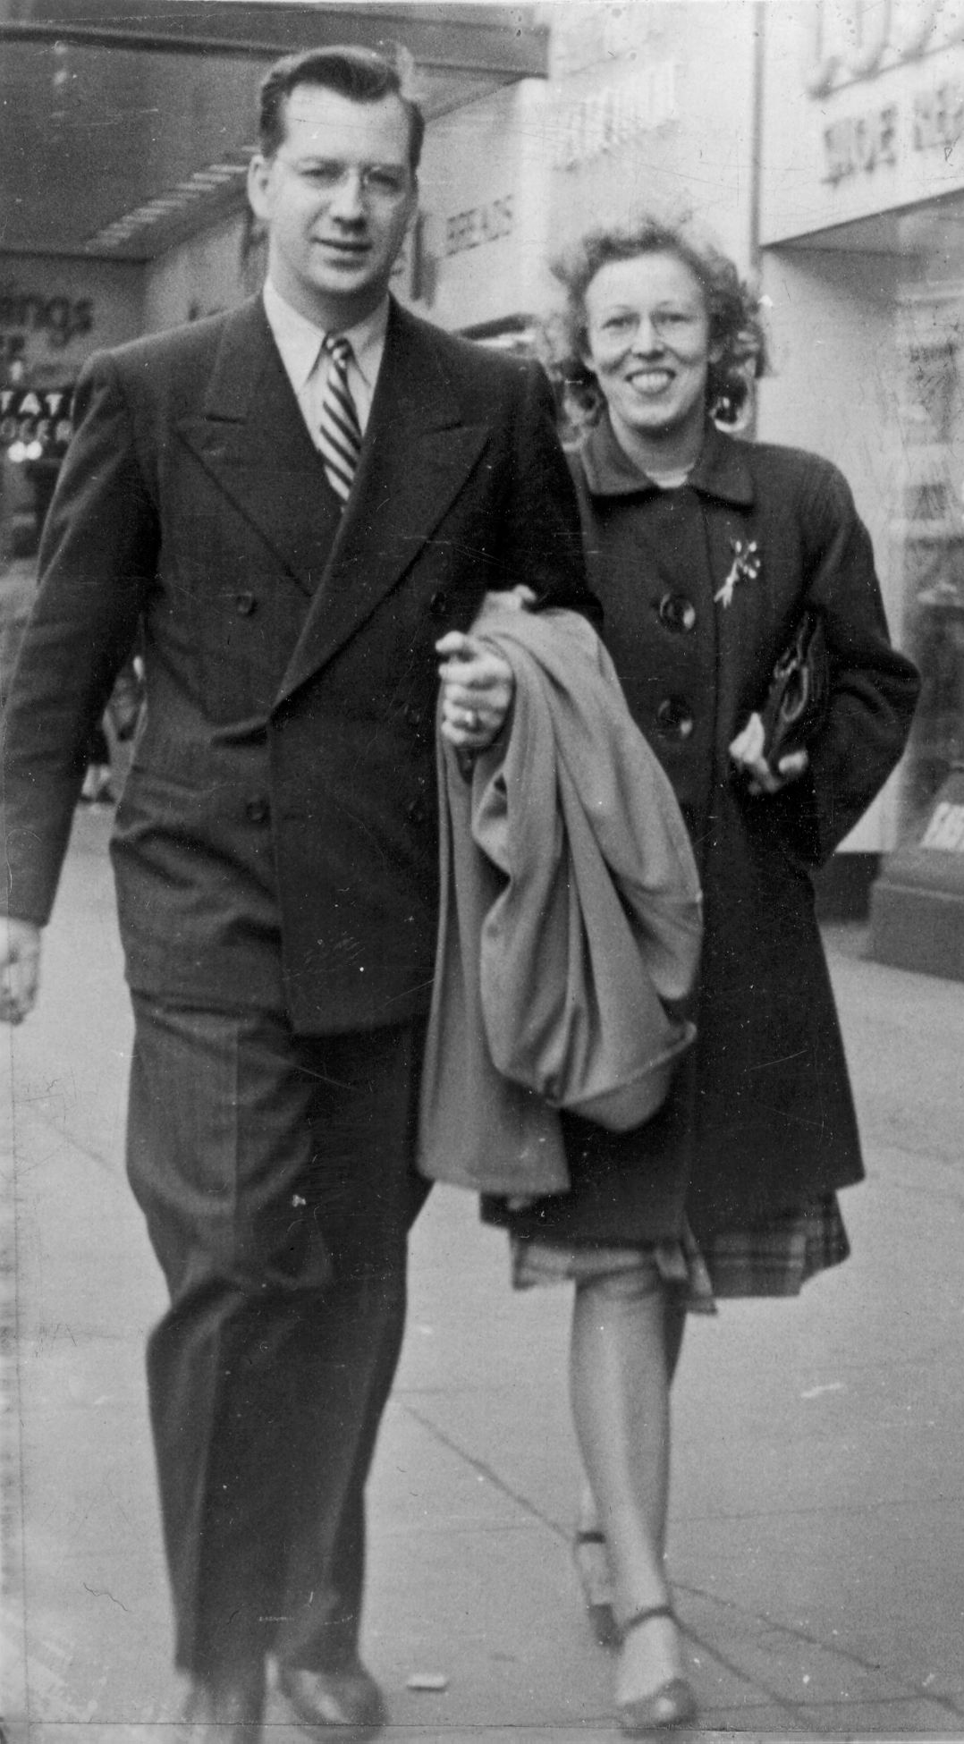  Glen and Beverly in 1944  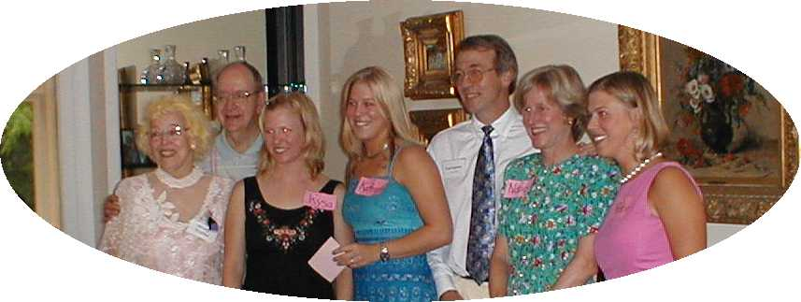  Family at Beverly and Glen’s 60th Wedding  Anniversary Party held June 17, 2000  The Nygreen family thanks you for coming and invites you  to join them after the service for a reception in Dyckman Hall  of the Scarsdale Congregational Church. | February 26, 2010  A Service of Thanksgiving  Celebrating the life of  Glen T. Nygreen  1918-2010  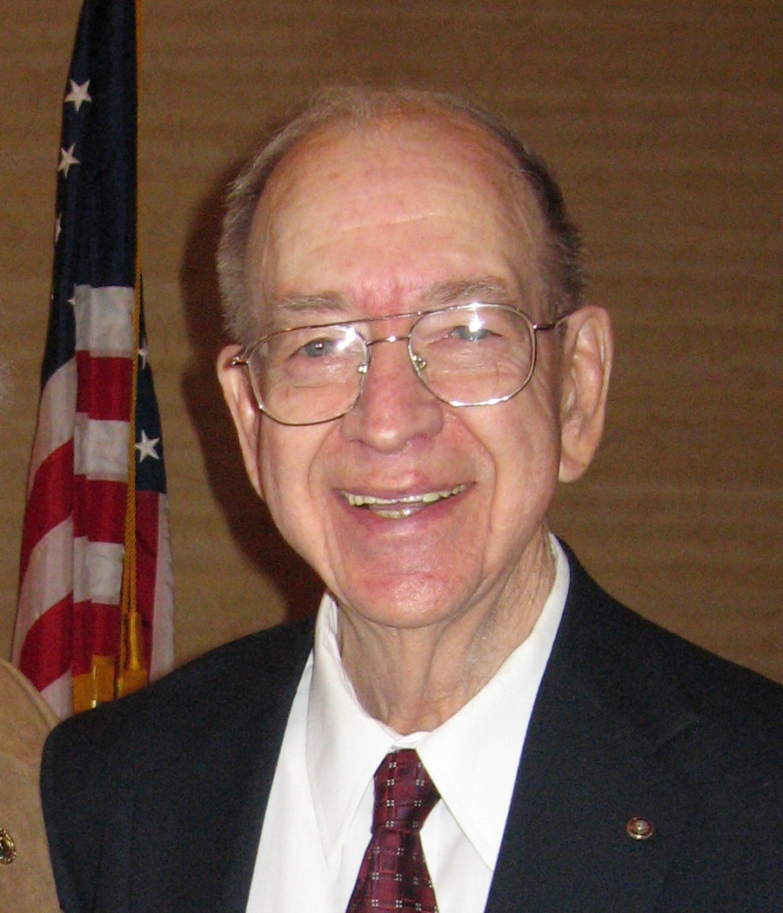  Scarsdale Congregational Church  Scarsdale New York  http://nygreen.com/family/obits/Glen.htm

Memorial Service  In celebration of the Life  of  Glen T. Nygreen  August 11, 1918 – February 16, 2010  at  Twelve noon, February 26, 2010  The Scarsdale Congregational Church  ORGAN PRELUDE  CALL TO WORSHIP  *HYMN 452 O Day of God, Draw Nigh  (Let the people be seated)  INVITATION TO REMEMBER AND GIVE THANKS  OPENING PRAYER and LORD’S PRAYER (trespasses)  READING – Ben Sira (Apocrypha) 44: 1,3-4,7-8,10-15  PSALM 23 (unison)  The Lord is my shepherd; I shall not want. ² He maketh me to lie down in green pastures: he leadeth me beside the still waters. ³ He restoreth my soul: he leadeth me in the paths of righteousness for his name's sake. ⁴ Yea, though I walk through the valley of the shadow of death, I will fear no evil: for thou art with me; thy rod and thy staff they comfort me. ⁵ Thou preparest a table before me in the presence of mine enemies: thou anointest my head with oil; my cup runneth over. ⁶ Surely goodness and mercy shall follow me all the days of my life: and I will dwell in the house of the Lord for ever. | EPISTLE READING – 2 Corinthians 4:16 – 5:1  HOMILY  REMEMBERING GLEN T. NYGREEN  Ted Nygreen, son  Kysa Nygreen, granddaughter  Andrew Morzello, Rotary Past District Governor  Naomi Adler, United Way President  Edgar Roberts, Lehman College, friend and neighbor  PRAYER OF THANKSGIVING  * HYMN 464 Joyful, Joyful We Adore Thee  *PRAYER OF COMMENDATION  *BENEDICTION  *ORGAN POSTLUDE  *Those able are invited to stand.  Clergy  The Rev. Larry Kalajainen  The Rev. Frances Wise Grenley  Organist  Arthur Lawrence  Ushers  Peter Brandt, Harry Lennon  Lucy Werner, John Werner  Guest Book and Coordination  Lois Lennon, Michelle Elyachar  Reception  Bonnie Mitchell

