<http://brewerfuneral.tributes.com/show/Ruth-Nygreen-Cash-94353345>

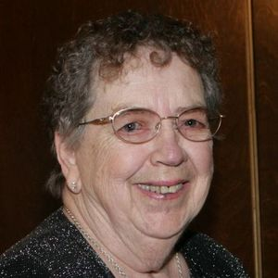

Ruth Nygreen Cash

April 14, 1927 - August 29, 2012

Clermont, Florida

Ruth Nygreen Cash, 85, of Clermont, FL passed away August 29, 2012 quietly at home under the loving care of her family. Ruth was born April 14, 1927 in Bellingham, Washington, moving to Clermont ten years ago from Salinas, California, where she previously retired as an x-ray technician at Salinas Valley Memorial Hospital. Ruth had a special interest in lighthouses, and enjoyed visiting and collecting them throughout her lifetime.

Ruth is survived by her beloved husband, Robert Cash, of Clermont, FL; her loving daughter, Linda Williams, of Clermont, FL; grandsons Gregory Williams, Jr. and Jonathan Williams of Chicago, IL; great-grandsons Michael Williams of Grenada, MS and Austin Moussa of Gainesville, VA; brothers Howard Nygreen of Colton, WA and Paul (Mary)Nygreen of Walnut Creek, CA; and numerous nieces and nephews. Preceded in death by her brother, Glen Nygreen.

In lieu of flowers, the family request memorial contributions to Cornerstone Hospice or the Alzheimer's Association.

Email from Linda Williams at ldwilliams57@gmail.com via BREWER on 9/29/2012